**Rock Climbing 101**

**Meets Tuesdays and Thursdays, 7-9 p.m.**

**Begins September 13, ends December 16**

**College Gymnasium, Room 104**

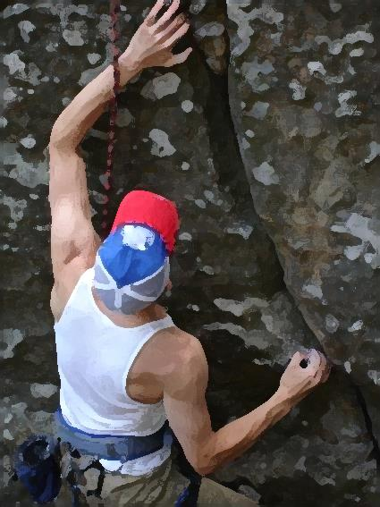

Increase your fitness level by learning basic rock climbing using the new Laurel College Gymnasium Rock climbing wall. The Physical Education department is offering Rock Climbing 101 as part of its Recreational Fitness Program.

You will participate in a challenging class that will help you burn calories and increase your strength. Rock climbing results in an exciting and sometimes strenuous workout. The class will help you relieve stress, and you may notice increased flexibility, improved posture, and better muscle tone.

Register for Rock Climbing 101 on the first night of class. Wear comfortable clothing, and bring a bottle of water. Before enrolling in this or any other exercise class, discuss your plan with your physician.

Improve your strength, balance, and coordination.